**Day-4**

NAME : **T. ASHWATH**

REG NO : 192011375

COURSE : SOFTWARE ENGINEERING

CODE : CSA1001

FACULTY : DR.MARY VALANTINA.G

DATE : 29/09/22

LAB MANUAL 18 to 25

18.Draw a Activity diagram for Online Railway Reservation System using CASE tools

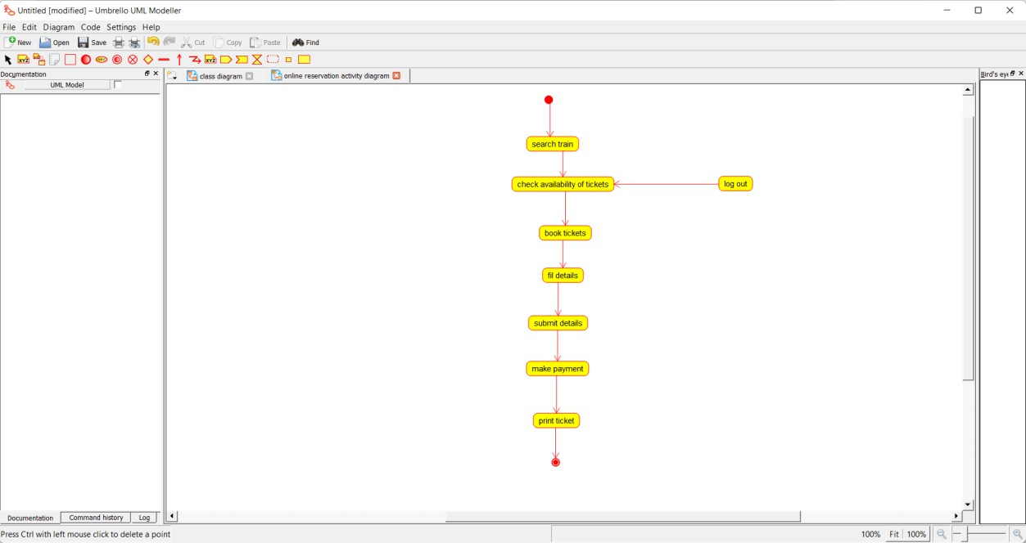

19.Draw a Activity diagram for Hospital Management System using CASE tools

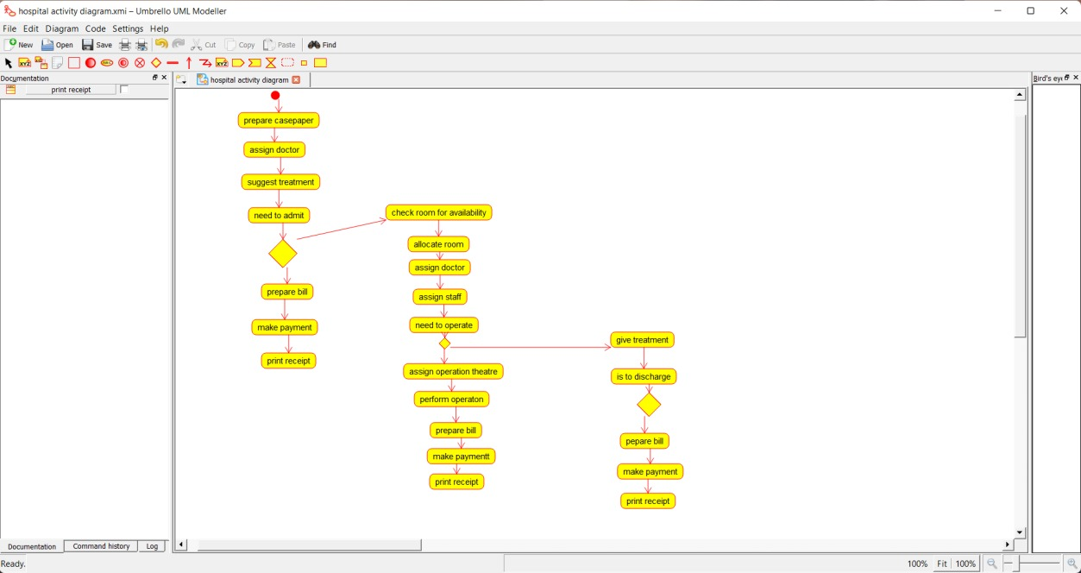

20.Using Raptor- Draw the flowchart to check whether the given number is a palindrome or not

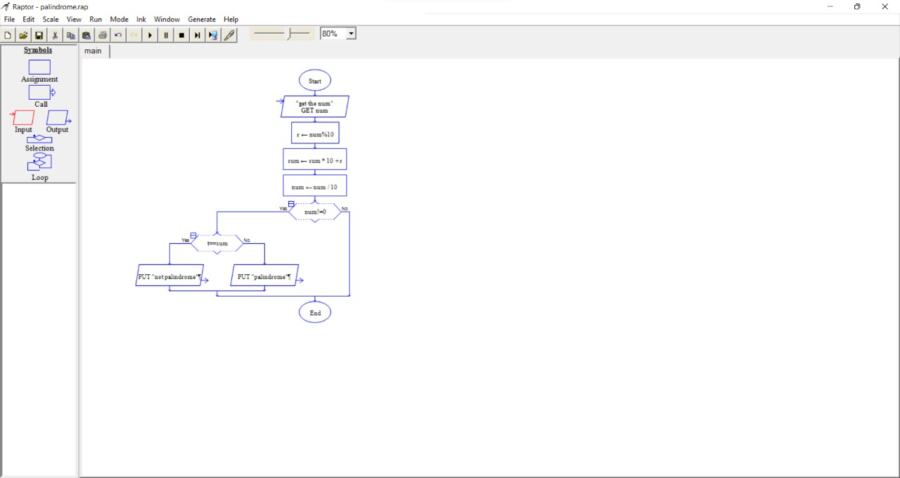

21.Using Raptor- Draw and validate the flowchart to calculate Fibonacci series.

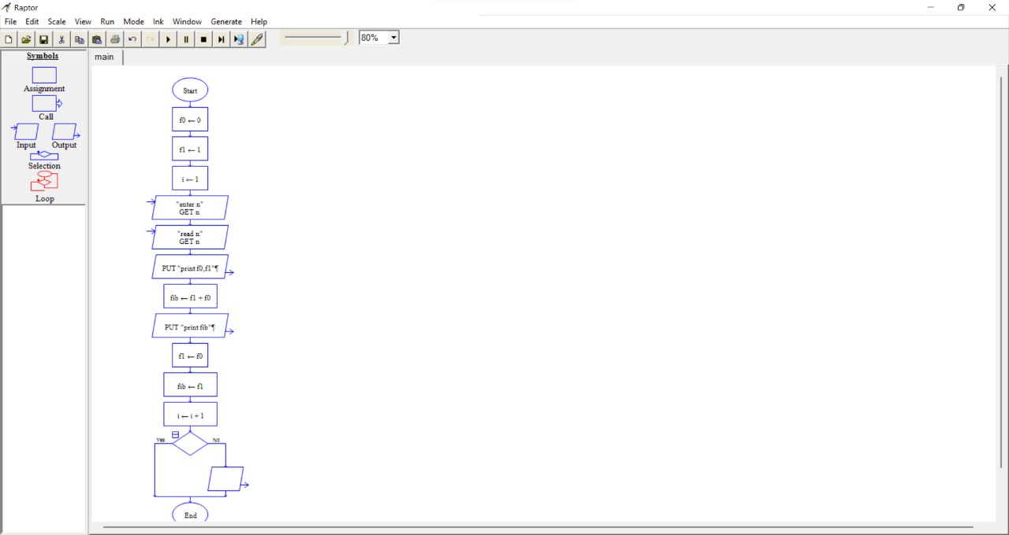

22.Using Raptor – Draw and validate the flowchart to swap two characters.

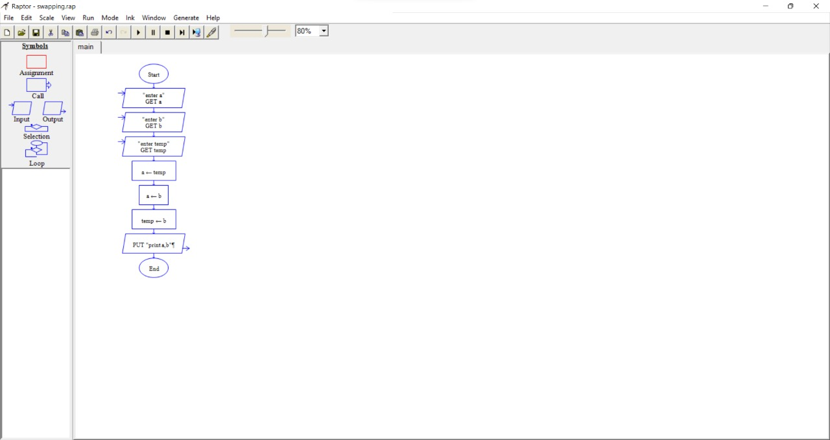

23.Using Raptor – Draw the flowchart to display the length of the string

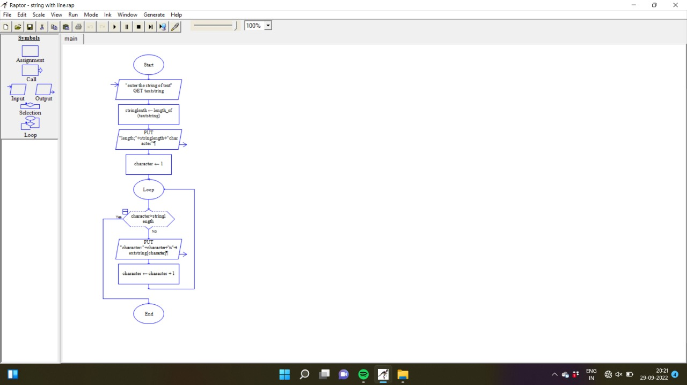

24.Using Raptor – Draw the flowchart to find whether the given number is prime or not.

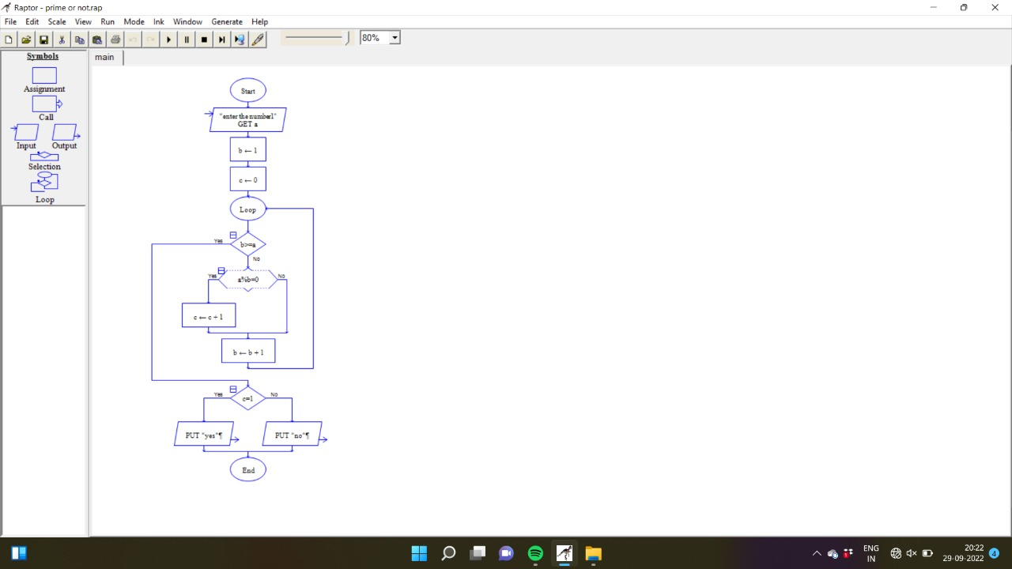

25.Find Cyclomatic Complexity for a graph having number of edges as 12, number of nodes as 13 and number of predicate nodes in the flow graph as 5.

